Lab - Performing an Offline Defragmentation of the Directory Database

Like other services in Server Manager, the Active Directory Domain Services can be stopped and restarted, without the need to shut down the Server. In this task, you will stop the Domain Controller service and perform a routine maintenance task.

1. Log on to Server 2012 as administrator

2. In the Server Manager window, select AD DS, scroll the right window pane down to Services, select “Active Directory Domain Services,” right-click and select Stop Services.

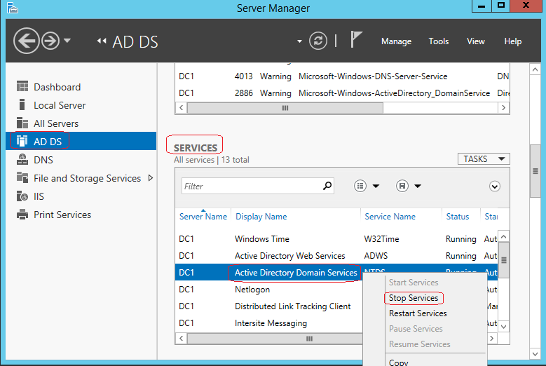

3. In the Server Manager warning dialog box, click OK.

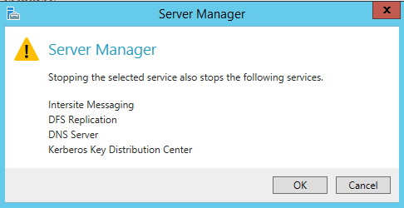

Note: Before stopping this service, all dependent services will also be stopped.

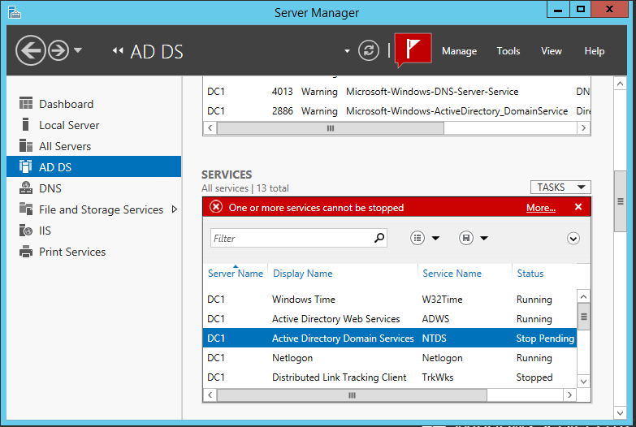

In the Hit the Win+R. At the run line, type cmd.

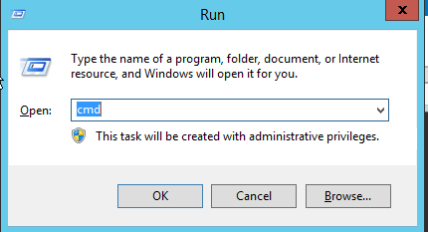

In the Command Prompt window type the following commands, pressing ENTER after each one.

1. ntdsutil

2. activate instance ntds

3. files

4. info

5. compact to c:\database

6. Once the database has been compacted,

type quit

7. Type quit one more time.

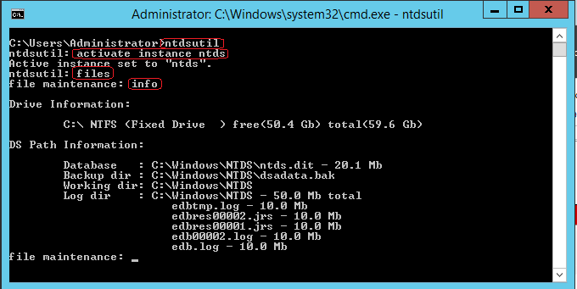

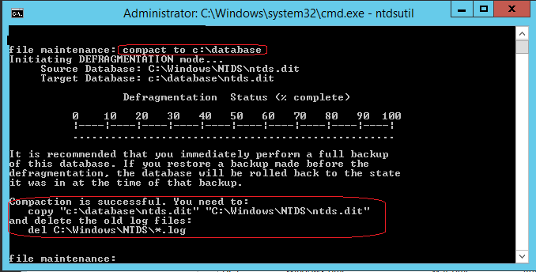

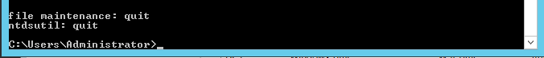

Note: This will create a compacted version of the NTDS.dit file. This process will take approximately two minutes.

Note: The go fixup command will run the database checker and fix any errors it encounters.

In the Server Manager window, click Start to start the Active Directory Domain Services service.

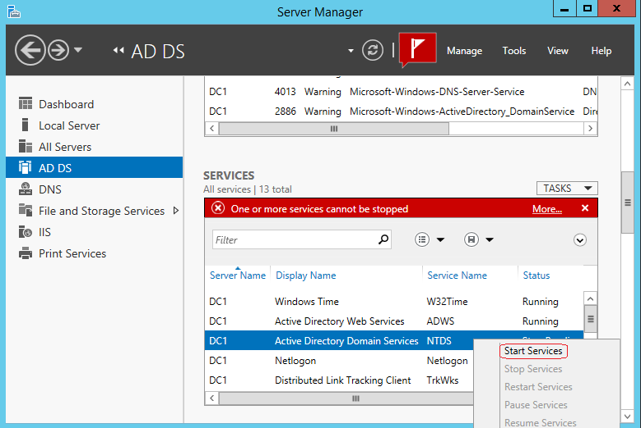

If the service refuses to start, reboot the Server.

End of the Lab!